FOI Casework Guide Hub

Foreword
FOI Casework overview – workflow diagrams
Investigation case workflow
ICE statuses
Case eligibility process
Sift
Received status cases
Initial eligibility checks
Gathering evidence
Accepting the case – admin tasks
Prioritisation
Completing the eligible case process
Allegations of criminal offences
Allocation processes
Naming case documents
Investigation cases
Priority cases
Decision Notices
Section 50(2)(c): frivolous or vexatious complaints
Closing cases
Service complaints
Working with FOI Policy
Monitoring and Enforcement
Upstream work
FOI Appeals Team
Decision notice appeals
Judicial Reviews

Foreword
This operating model provides a central hub for all our FOI casework processes and procedures and provides the framework for investigating FOIA and EIR complaints. It works alongside the ICO Service Charter and the Regulatory Manual that underpins our approach to strategic regulation.
As we work towards our ICO25 target operating model, we will update and amend this and the underpinning policies. It will be a living document that we update regularly.
We are committed to providing the best service possible and will measure this against our service standards:
- We will allocate prioritised cases within four weeks of the case being available for investigation
- We will allocate all other cases within 12 weeks of the case being available for investigation
- We will complete 90% of cases within six months of receipt
- We will have fewer than 1% of cases older than 12 months

This document sets out the key principles and processes that will help ensure consistency, efficiency and proportionality in FOIA/EIR casework. However it cannot replace the judgement and expertise of ICO case officers. The investigation and handling of any particular case will always depend on the specific circumstances of the case, and may not follow every process set out in the document.

FOI Casework overview
This high level diagram describes the workflow from receiving a new complaint to allocating a substantive investigation case.
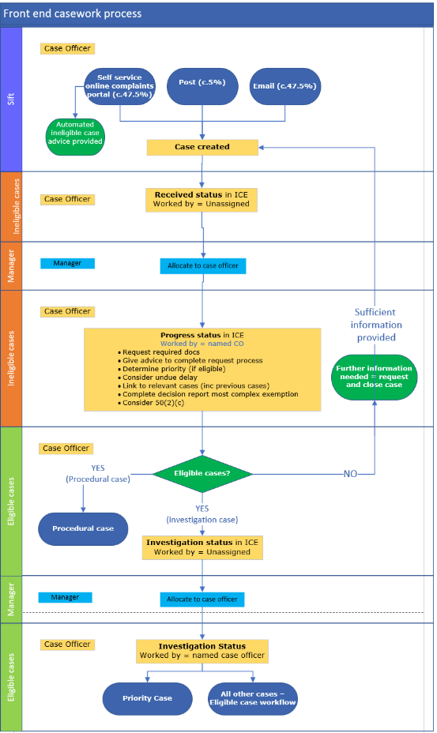

Investigation case workflow
This is the basic workflow for a standard investigation case. Use it as a guide for most casework scenarios. Some situations will fall outside this and you should discuss the best way forward with a manager, mentor or experienced colleague.
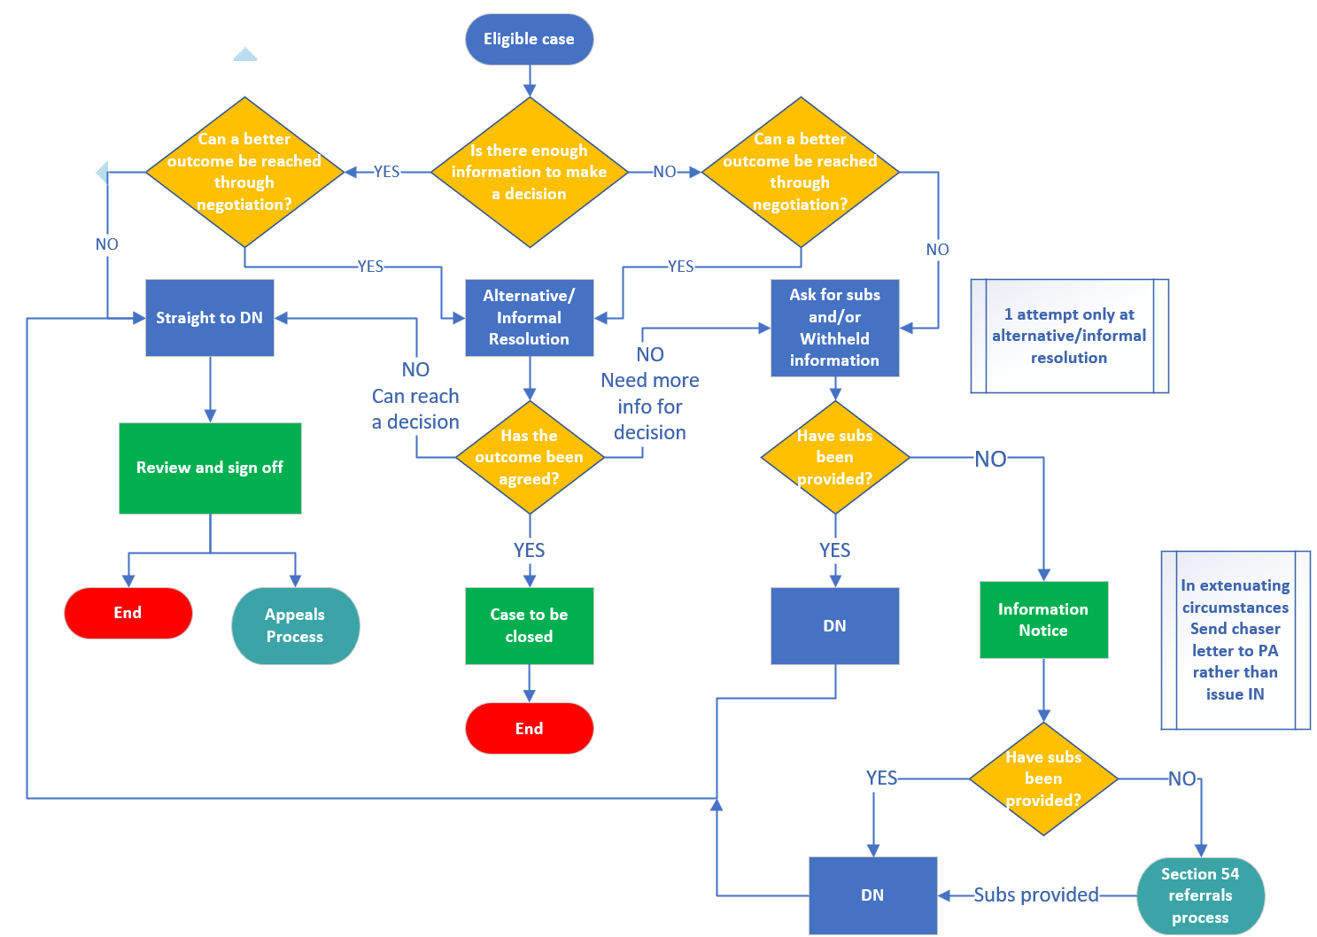
To ensure that this process is streamlined, it is important to have in mind that in most cases, there should only be one attempt to resolve a case through informal resolution techniques. If the attempt is unsuccessful or incomplete, you should move to either request submissions and/or withheld information from the PA, or proceed to a DN. Case officers should not engage in lengthy informal resolution attempts which place an undue strain on our ability to meet KPIs or impact on their wider casework.
The decision on whether to try alternative/informal resolution should be guided by asking whether this could achieve a better outcome for the parties involved. If not, proceed to either drafting a DN or asking for submissions.

ICE statuses
This table shows the way each status in ICE will be used. Make sure your case is in the correct status for the stage you are responsible for.
Case status | Reason
Received | This is the case status when the case is created. It will stay like this until someone is assigned to work on it.
In Progress | This status is for when you are assessing whether the case is eligible.
Completed | If a case is not eligible, or if we do not have sufficient information to accept it for investigation, the case should be closed. If we receive the information, a new case will need to be opened. This status will also be used when an investigation is completed.
Investigation | Once a case has been set as eligible it will be moved to this status. This includes non-response cases. As soon as you identify that the case is a non-response case, move it to investigation.
Awaiting Further Evidence | When you are waiting for the PA to reply to us we will use this status. This will let us see at any one time how many cases are with PAs for action.

For a detailed guide on how to use ICE360 see here.

Case eligibility process

Sift
New cases come to us one of 3 ways:
- Customer Journey on ICO website via our complaints portal
- Emails to @icocasework
- Postal letters
The correspondence is sifted to either add to a relevant case or to create a new case. For detailed processes and advice, please refer to the Sift Guidance.

Received status cases
New cases are in ‘received’ status in ICE. Managers will allocate ‘received’ cases to Case Officers. Case Officers will work these as ‘in progress’ cases and complete the following tasks. Please refer to the Checklist for Received and In Progress cases spreadsheet for a full list of tasks. Please use the template letters in Sharepoint to guide your responses.

Initial eligibility checks
- Is the complaint about a specific request for information, and is the requested information clearly identifiable from the request?
- Was the request made by the complainant (who can be an individual or acting obo an organisation) or, if made on behalf of the requester, do we have clear authority to deal with the nominated person?
- Is the complaint about a public authority under FOIA/EIR and not a Scottish public authority?
- Is the request for the customer’s own personal data?
- Has there been an undue delay – more than 6 weeks since the last exchange of meaningful correspondence related to the request? Was the request made within the last 6 months? Guidance on considering whether there has been an undue delay is available here.
- Is the complaint obviously vexatious or frivolous?
- Has the complainant been through internal review? In most cases if they have not been through internal review the complaint will not be eligible. However, there are situations in which we will accept a case without an internal review having been completed. Guidance on this is available here.

Gathering evidence
- Do we have the right evidence to take the case forward?

Case type | Request | PA response | Internal review request | Internal review response
Timeliness | ü
No internal review | ü | ü | ü
Substantive | ü | ü | ü | ü

- Do we have clear grounds for complaint?

Grounds of complaint should be specific enough to identify the particular element of the request the customer is unhappy with, for example:
- the application of the exemption
- the delay
- the public interest test

Our remit is to make a decision on specific matters raised by the complainant. For this reason we need complainants to tell us what they are complaining about, rather than saying “see attached” or “please investigate”. You will help complainants to clarify their complaint, but you will not go through correspondence to construct complaints. It is the responsibility of the complainant to provide the grounds of their complaint.

- If you do not have the right information to start a case you will ask the customer to send it to us, and/or provide advice to finish the request process. You will give the complainant a deadline to respond. 28 days is the deadline we set in our further information letter. You will then close the case.
- When the customer provides us with all the information we need, you will open a new case. Send an email from the closed case to the new case with the relevant documents attached and upload as required.
- If the customer comes back outside of the deadline, consider handling as undue delay.
- If the customer comes back with more questions or is still yet to exhaust the public authority’s complaint process you will need to provide further advice and guidance on the closed case without opening a new case.
- If the request is for the complainant’s personal data, the case will be set up as a data protection complaint and allocated to Public Advice and Data Protection Complaint Services (PADPCS).
- Where a complaint includes a request for the complainant’s personal data in addition to other information, separate cases will be set up for the data protection and FOIA/EIR elements to be investigated. You may need to consult with colleagues in PADPCS to ascertain the correct access regime or regimes.

If you cannot identify a valid request, or assess that a complaint is otherwise ineligible, you will explain this to the complainant and let them know whether there is anything they can do to resubmit an eligible complaint.
If a complaint is ineligible it will be closed. If the complainant provides the information we need to assess the complaint as eligible, within 28 calendar days, then a new eligible case will be set up. If the complainant provides this information after more than 28 calendar days you will reject the case as out of time.
You should not engage in lengthy exchanges with complainants in order to assess eligibility of a complaint or to identify relevant documents as requested in the portal.
You will allow complainants one further chance to provide adequate or appropriate information. If the complainant fails to do so you should not set up a new eligible case unless there are exceptional circumstances.
If a complaint is closed as ineligible you will not usually inform the PA that the complaint was received. However you may log it on the intelligence tracker if it indicates evidence of poor or concerning practice. Guidance on using the intelligence tracker is available here.
We can only issue a decision notice in respect of a request for information, but sometimes people will share relevant information about compliance issues involving PAs. For example, this could be a PA’s failure to adopt a publication scheme, or a pattern of responding late to requests for information.
In such circumstances, you will set up a case as usual on ICE and flag in the case title that it relates to insight information rather than an individual complaint. The case should be closed as “Not FOI”.
You will record relevant information on the intelligence tracker. You may also flag the issue with the relevant group manager or casework lead.

Accepting the case – admin tasks
Follow the ICE case handling process and matrix for In Progress cases to ensure all admin tasks are completed correctly.
- Are all the relevant documents on the case (if a new case has been set up, ensure relevant documents are copied)?
- All relevant parties added?
- Do we have any linked cases?
- If we have created a new case on receipt of additional evidence, make a record of the linked case on a file note – can use a hyperlink
- Check the customer contact record for linked cases
- Check the customer journey complaint form for linked/related cases
- Create a file note and add hyperlinks to linked cases. Name the document LINKED CASES
- Correct case title and document names?

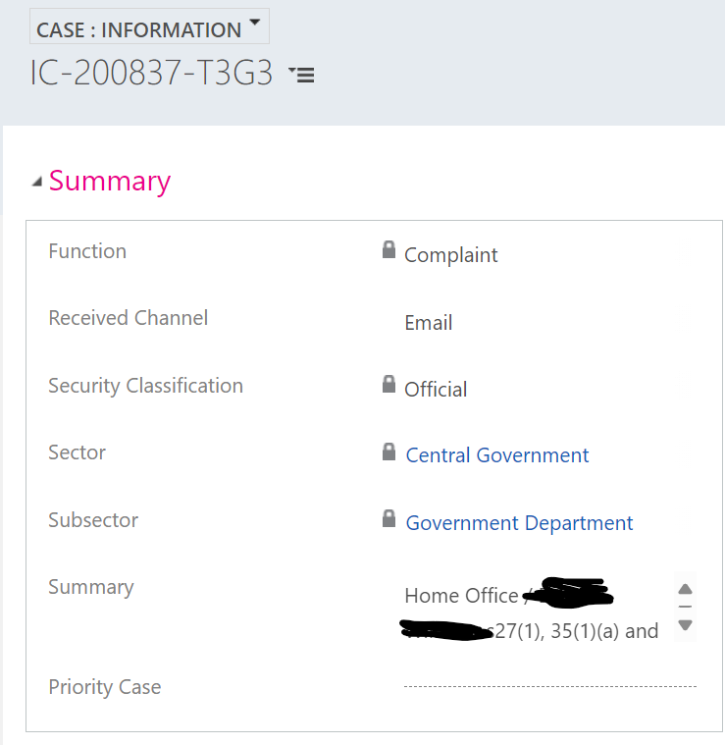

  - Case:Information summary updated with case title: “Public authority / Requester [applicable sections/regulations – s10 r5(2)]”

  - Refer to the naming convention document for specific document titles.
- Decision report updated to include all relevant sections/regulations in scope of the complaint (most complex listed as primary) see ICE matrix. For example, if the complainant says they accept the personal data redactions, you don’t need to include s.40 personal data exemptions on the decision report.
- The decision primary reason should be the most complex substantive element of the complaint. In the example below, section 27 was engaged for the majority of the requested information.
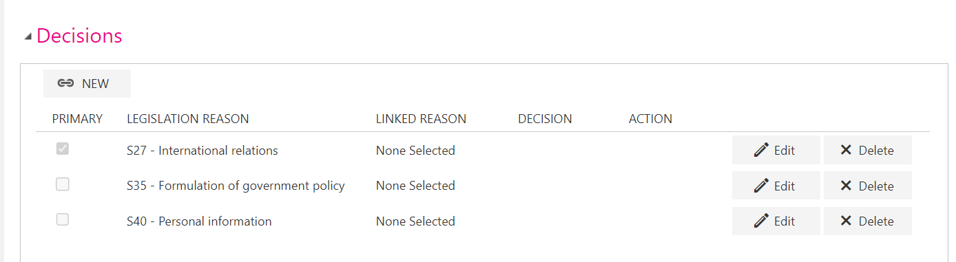

Prioritisation
- Does the request meet any of the criteria? Follow the guidance on applying the criteria in the Prioritisation Decision Making document. If you are unsure discuss with an experienced colleague or manager.
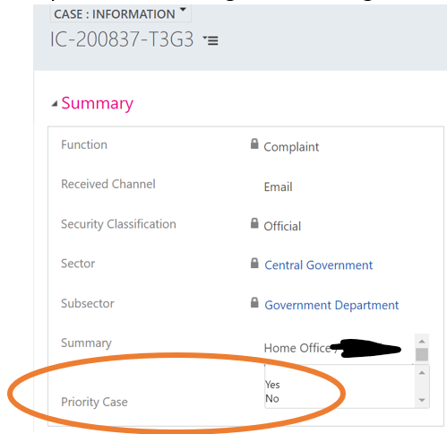
- Once you have assessed the request against the criteria and made your decision, you will update the CASE : INFORMATION tab.
- Select yes if the case is a priority. Select no if it is not. Leaving it blank tells us that it hasn’t been assessed for priority.

Cases must only be marked as a priority at the In Progress stage by the triage case officer and then accepted for Investigation. They cannot be marked as a priority at any later stage in the handling of a case. If at a later stage of a case it is recognised as high profile, it can be marked as such by using the separate High Profile marker on the Complaint: Information tab in Case: Activities.

Completing the eligible case process
Send the case acceptance letters to the complainant and the public authority. This will tell the complainant that they have submitted an eligible case and will inform the public authority that we have accepted the case for investigation.

Allegations of criminal offences
Complainants may allege that a public authority has committed an offence, most commonly in relation to section 77 of FOIA. Section 77 details that an offence will have occurred when a person
“alters, defaces, blocks, erases, destroys or conceals any record held by the public authority, with the intention of preventing the disclosure by that authority of all, or any part, of the information to the communication of which the applicant would have been entitled.”
Early identification of s77 offences is crucial to conducting a prompt investigation within the six month timescale set out in the legislation. However, referrals should only be made to CRIT if you consider there is a prima facie case to support a s77 allegation. If you consider that any s77 allegation is either baseless or spurious do not refer it to CRIT. Consult with your manager and/or CRIT if you’re unsure as to whether a case should be referred on that basis.
If you think there has been a possible section 77 offence you will complete the section 77 referral form from the Case resources area of SharePoint.

Allocation processes
- Received allocations
  - Team managers to allocate the received cases to their team.
  - Priority investigation cases
    - Managers to consider Priority cases in the first instance when allocating to their teams. They will take into account the number of Priority cases a case officer may already have in their work queue to determine capacity, as well as the case officer grade and experience, skills and sector.
  - All other investigation cases
    - Allocate these cases after priority cases have been allocated. Allocate in date order based on the ‘Received on’ column in ICE. Base allocation on case officer grade and experience, skills and sector.

Naming case documents
It is your responsibility to ensure that ICE documents are appropriately named in every case that you are allocated. Following the naming convention document is a compulsory step that you must carry out in every case allocated to you. Every document on the case must be labelled.

Investigation cases
As soon as a case is allocated to you, you must assess it to decide the appropriate course of action. You should aim to do this as soon as possible once the case is in your work queue.
Each of the case handling options has a dedicated process document which you can access through the below links. The following provides some high level guidance to help you decide which option is most appropriate for your case:
- Straight to DN
- you have enough information from the refusal notice and the internal review response to uphold the PA’s position and you do not need to see the withheld information. Proceed to draft a DN.
- Alternative and informal resolution
- You can attempt alternative or informal resolution either as your first contact with the parties or, after you have received the PA’s submissions and/or the withheld information.
- Attempt alternative resolution by phone in the first instance where possible.
- You should limit informal resolution activities to one attempt per case. You should not become involved with protracted correspondence.
- You can negotiate with the customer to accept our view or suggest a more appropriate course of action to resolve their concern. You can rely on precedent cases and your experience.
- You can negotiate with the PA for the disclosure of some or all of the requested information or to discuss refined request options.
- Set deadlines for the customer to come back and confirm if they accept the position – five working days and make it clear what will happen if they don’t confirm – which is that we will close the case/issue DN. If the customer outlines compelling reasons for an extension of this deadline, the case officer may take these into account.
- Set deadlines for the PA to disclose any additional information – five working days (or as agreed with PA up to 20 working days) and make it clear what will happen if they don’t – eg issue a DN ordering disclosure/require formal submissions.
- A detailed guide to alternative resolution of cases including by using dispute resolution techniques is available here.

- Request submissions and/or the withheld information
- You will assess the quality of the PA’s response and internal review response (if present). If you don’t have enough information to reach a decision, or if you need to see the withheld information to confirm a view, you will need to write to the PA to ask for the information you need.
- You will put case in Awaiting Further Evidence when waiting for PA response (including when waiting for Information Notice responses).
- As stated below in most cases you will set a 10 working day deadline for their response. Consider shortening this if you are only asking for limited information (i.e. just the withheld information).
- You will make it clear that if the public authority changes their position they must provide us with submissions and inform the customer of the new position within 10 working days (unless there is clear reason to agree a longer deadline).
- Remember to diarise the deadline either in ICE or your own Outlook calendar.
- When writing to a public authority for submissions you should give a deadline of 10 working days. If the public authority seeks an extension you will usually grant it in the first instance, generally allowing a further five working days. You should not grant repeated extensions.
- If the public authority has failed to respond with submissions by the extended deadline following a single extension request, you will progress the case to a decision or information notice.
- At this stage if you can issue a decision without needing further input from the public authority, you should. This will include cases where you do not anticipate ordering a decision notice step or where the step would be to issue a ‘fresh response’.
- If you can’t issue a decision without needing further input from the public authority (particularly in cases where you require sight of the withheld information) you should issue an information notice as soon as the public authority misses the extended deadline you have set.

- Using external weblinks in decision notices
  - It can be useful to include links to external websites in decision notices. For example, this may be to something that is available on the website of the public authority, or to a media article. Often this will be to provide background to the decision.
  - Where a decision notice is appealed a problem can arise if a web link in the notice no longer works by the time of the hearing. For example, if we have relied on a link to a public authority website as evidence that information was available, it may not be possible to evidence that during the appeal if the link no longer works.
  - To address this you should add a record to the ICE case file that shows what was available at any external weblink included in a decision notice, at the time that the decision notice was issued. An example of how to do this would be to add a word document with a screenshot of the relevant web page as it appeared when the DN was issued.

- Recording procedural breaches
- Where there has been a procedural breach in the handling of the request, you should consider whether to record this by finding the breach in the decision notice.
- You have discretion as to whether you find procedural breaches in DNs and this is not always necessary, such as where the procedural breach is minor or inconsequential.
- In some cases a procedural breach will be the subject of the complaint; timeliness complaints most obviously. In those cases the decision notice should of course record the procedural breach.
- In cases with a different focus – exemption cases for example – you should consider whether there is a purpose to finding a procedural breach, such as if the breach is serious enough to merit a DN finding or you believe that recording the breach in a DN would help to improve the practice of the public authority.
- Whether or not you include a procedural breach in a DN, you should ensure that you record any concerns about the public authority on the intelligence tracker. Guidance on using the concerns tracker is available here.

Refer to the ICE matrix for investigation cases for the relevant ICE processes, including outcomes and data to record in the decision report.

Priority cases
Priority cases can be worked by any case officer according to its complexity. We will allocate priority cases before other cases and expect that you will treat the case as a priority within your own workload. You will know that a case is a priority because it will have a yellow priority case banner in ICE.

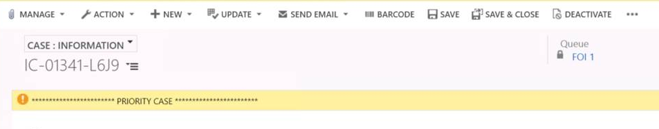
Prioritised cases will be handled in the same way as business as usual cases, but you will action any priority case in your queue ahead of all other cases and other activities you may be undertaking. You will be prepared to set shorter deadlines for public authorities. It may be necessary to consider the wider caseload of a particular public authority to balance priority cases against business as usual cases. If you think this may be appropriate, speak with your manager.
If you need internal advice or guidance on a case, for example from FOI Policy or Knowledge Services, you will make it clear that the advice is needed for a priority case and agree a suitable deadline. This can be done over the phone or by email to reduce delays.
Prioritisation does not mean predetermined outcomes. You will investigate prioritised cases in the same way as all other cases, applying the legal tests in the same way and with the same level of consideration.

Decision Notices
The Decision Notice process contains a number of steps which are covered in detail in the ICE360 DN process guide.
This is the process for most cases requiring a DN. Experienced senior case officers may be authorised as signatories, and in that instance only a peer review will be needed if applicable. In addition, if a signatory (TM or GM) is reviewing and signing your DN, they will only need to review it once.
DN reviews must follow the approach set in the guide to decision notice reviews.

Section 50(2)(c): frivolous or vexatious complaints
Section 50(2)(c) of FOIA says that the Commissioner is not required to make a decision in respect of a complaint that is frivolous or vexatious.
If you believe that a case may engage section 50(2)(c) you should consult the detailed guide on this provision. As per the guide you should discuss a possible reliance on section 50(2)(c) with your manager.

Closing cases
When closing cases you must carry out the tasks listed here and here, including by ensuring that the correct fields are completed on ICE and that all case documents are appropriately stored and named.

Service complaints
Parties may appeal a decision notice if they disagree with the Commissioner’s decision. If they are unhappy with the service they have received, this is not a matter that can be decided by an appeal. In such cases the applicant may submit a service complaint.
It is important to remember that a service complaint will only consider the way a complaint is handled. It cannot consider the outcome of the complaint, and cannot change the Commissioner’s decision. If a complainant challenges the outcome of a decision notice, they should be advised to submit an appeal. You should not treat this as a service complaint.
If an applicant indicates dissatisfaction with the service we have provided you should consider whether further explanation would be helpful. If not, or if this does not resolve the issue, you should explain how the applicant can make a service complaint.
On receipt of a service complaint you will issue an acknowledgement, advising that the complaint will be considered by a manager. You will follow the correct process to record the service complant in ICE360. You will then alert your manager to the service complaint having been made. Your manager will respond within 30 days from receipt of the service complaint with their findings and will advise the applicant of their right to complain to the PHSO. If the manager will not be able to reply within 30 days they will contact the complainant to update them.

Working with FOI Policy
FOI Policy is the Policy team within the FOI and Transparency Directorate The team provides a number of policy outputs including:
- Providing FOIA and EIR policy advice.
- Reviewing policy implications of relevant tribunal and court decisions.
- Providing lines to take and policy positions.
- Creating and updating external facing guidance on FOIA and the EIR.
Before contacting FOI Policy, you can explore our existing resources such as:
- The FOI knowledgebase which contains our lines to take, policy positions, policy reviews of legal decisions.
- The detailed, external facing guidance.
- Our interactive tool on ‘Is the organisation a public authority under FOI?’
Following this, if you still need advice on how to interpret a particular section of the legislation or want support on considering the implications of a tribunal decision then you can contact the FOI Policy team on: foi.policy@ico.org.uk.
To get the best response from FOI Policy here are some hints about what to include in your email:
- Be clear about the policy question you are asking.
- Remember that the policy team can’t make casework judgements.
- Provide any useful context or background.
- Let them know where you have already looked for advice.
- Tell them about any time constraints on the advice you need.
- Confirm if the case has been prioritised under the prioritisation criteria.
FOI Policy will be able to deal with most queries within their team, but they may need to redirect your query to other teams such as Knowledge Services or Policy Legal if they are better suited to providing the advice you ask for. For example, Knowledge Services deal with enquiries related to whether an organisation is a public authority under FOIA or EIR as they maintain a log of such advice.
If you are unsure whether it is policy or legal advice you need, FOI Policy will be happy to help determine the best route.

Monitoring and Enforcement
The Regulatory Manual provides the basis for our monitoring and enforcement activity.
You should record all concerns identified through day-to-day casework as they arise on the intelligence tracker. This allows for specific issues, for example timeliness and inappropriate use of exemptions, to be recorded in a consistent manner and enables the managers to track emerging issues to inform strategic considerations.
If you have a strong concern about an individual case, you should consider what action could be taken and discuss with your manager immediately.
Examples of this include, but are not limited to, the following:
- The PA has a significant backlog of requests.
- The PA cannot process requests for some reason.
- The PA is obviously failing to engage on a case.
- The PA is clearly failing to comply with provisions of the Codes of Practice.
- The PA has approached you to raise awareness of issues with their performance.
Please record all instances of concerns. We need this intelligence to take regulatory action.

Upstream work
The Upstream Regulation team supports public authorities to perform in line with their statutory duties and prevent breaches of the legislation from occurring in the first place. In turn this should reduce the need for internal reviews and complaints to the ICO.
We have published lots of tools and resources to help public authorities comply with the legislation and improve openness, accountability and transparency. You can signpost public authorities to these resources during the course of a case if you identify any support needs.
You should also make sure you update the concerns trackers if you provide these resources in response to a concern.
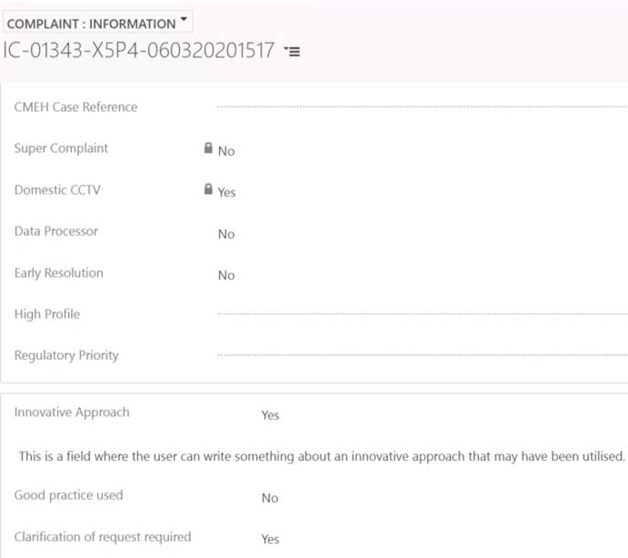
To shape and support the future work of the Upstream Regulation Team we are currently capturing casework information about good practice we see in the course of our cases, and also instances where the public authority needs to seek clarification of the request.
When you spot instances of this in your cases, please ensure you complete the relevant field in ICE in the COMPLAINT : INFORMATION tab. You will need to select yes or no and add a brief summary in the free text box.

The table below explains in more detail what sort of information we are looking for and why we need it.
Good practice | Clarification of request
What are we capturing?
Any instances of good practice. | Any instances when the public authority has had to seek clarification of the request.
Why are we capturing this?
For case studies  So that we can contact the public authority to drill down into their good practice and create a case study for other PAs to learn from. | For clarity in request making  So that we can gather examples to increase our understanding of how we can support members of the public to make an FOI request which will provide clarity to public authorities and make requests easier to handle.
How do we decide when to do this?
What is good practice?  Good practice could relate to either of the Codes of Practice under s45 or s46 FOIA.  It could also relate to something not stipulated in the Codes of Practice. | What is seeking clarification?  Requests that required clarification prior to issuing a substantive response.  This may be because; there is no objective way to interpret the request, or the request isn’t sufficiently clear to enable the public authority to identify or locate the requested information.
Examples (these are non-exhaustive)  Making it easy and straightforward to submit requests, online or otherwise.  Providing a comprehensive record of searches to support ‘information not held’ cases.  Interpreting requests broadly, in the spirit of FOI, thereby making more information available.  Proactively publishing information on ’hot topics’. | Examples (these are non-exhaustive)  Difficulty separating a request linked to ongoing or previous dealings with the requester.  Requests that are too general and unspecific, requiring clarification on timeframe and other scope-related information.  Unnecessarily broad requests suggesting a fishing expedition.

FOI Appeals Team

Decision notice appeals
Every decision notice advises the complainant and the public authority that they may appeal the decision to the First-tier Tribunal (Information Rights). Any notice of appeal should be served on the Tribunal within 28 calendar days of the date on which the decision notice is sent.
Occasionally both parties will appeal different elements of the same decision notice, for example where the Commissioner orders some of the requested information to be disclosed but finds that the remainder may be withheld.
Appeals are submitted directly to the Tribunal, who will tell us about the appeal and provide a copy of the appeal documentation.
When the Commissioner is notified of an appeal, a lawyer from the FOI appeals team will be allocated to the case and they will defend the appeal on the basis of the ICO’s standing instructions. The legal team will contact the case officer to ask for confirmation that all the relevant documents are on ICE and are properly labelled according to our naming conventions. They will also provide you with details of the appeal and any other relevant information.
In some cases and as required, the lawyers who are defending a decision notice will seek specific instructions from you and/or the signatory, for example if the public authority introduces a new exemption at the appeal stage. If you are unsure about what instructions to give, consult with your line manager or another senior colleague.
If correspondence comes into ICE regarding an appeal case you will contact the assigned lawyer or the FOI appeals team to let them know.

Judicial Reviews
A judicial review is a type of court proceeding in which a judge reviews the lawfulness of a decision or action made by a public body. In other words, judicial reviews are a challenge to the way in which a decision has been made, rather than the rights and wrongs of the conclusion reached.
Whilst decision notices can be appealed to the tribunal, other elements of our service can only be challenged through a judicial review. For example when we refuse to handle a complaint under section 50(2)(c) of FOIA.
If correspondence is added to a case that indicates a judicial review may be brought or suggests that the complainant is trying to bring a judicial review against the Commissioner, you will inform your manager and contact the FOI appeals team, and follow the referral process detailed here, as soon as possible.

